## Exercise: Shoppinglist extended – using events

Goal: to learn how to use a eventlistner in javascript

Events: <https://developer.mozilla.org/en-US/docs/Learn/JavaScript/Building_blocks/Events>

The task is to add more functionality to the shopping list to make it possible to dynamically enter items to the shopping list.

Do this:

1. Use the same repo/codebase as for the shopping list

As you can see, there is already some HTML in index.htm. You must expand the HTML code so that you get the following:

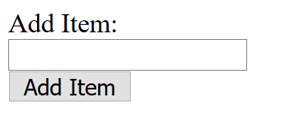

1. Add an EventListener so when you press the button then a new item is added to the shopping list with the text that is in the input field.
2. Now, create a function that includes all the functionality needed to add an item to the list.

You must use the following methods: createElement, set attribute, createTextNode, appendChild

Tip: You can grab the text in the input field by using the "value".

|  |
| --- |
| let inputText = elementInput.value |

1. Use the debugger tools if it doesn’t work as expected.
2. Consider how you could code a function that will give you the next unique number in the shoppinglist that you could then use for the id attribute when creating a new List element.
3. Create some functionality so that it is possible to state if the grocery is healthy or not healthy and use this information then you create the new item, so you can see it in the list.

Extra:

When you tap an item in the list, it should be hidden. Use the "hidden" attribute and set it to true.

If you subsequently want to display it again, you can delete this attribute with Removeattribute (' hidden ')